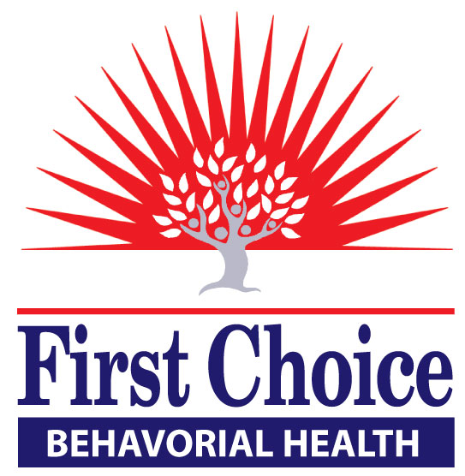

Buprenorphine Treatment Program Guidelines
Project Renew

First Choice Community Healthcare

First Choice Community Healthcare offers Medically Assisted Treatment to help those patients who meet criteria for Opiate dependence. The program includes primary care and individual and group counseling using the evidence based “Stages of Change Model of Addiction Treatment.” In addition, each patient is assigned a Community Health Worker that will address barriers and link to resources to help maintain a successful long term outcome.
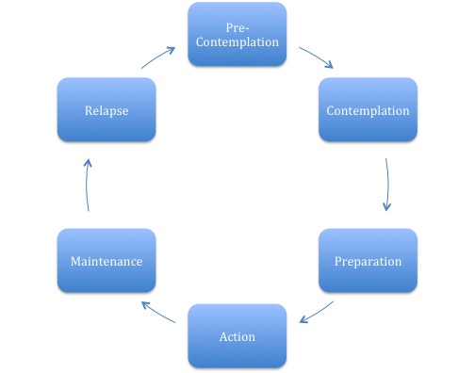
Definition of Recovery
“A process of change through which individuals improve their health and wellness, live a self-directed life and strive to reach their full potential.” Four dimensions that support a life in recovery are health, having a secure to place to live, meaningful daily activities and relationships that provide support. SAMSHA Definition of Recovery.
Evaluation/Intake
- Patient sees the behaviorist and completes within the first two sessions:
- Biopsychosocial assessment (With checklist for DSM-V diagnosis of opioid dependence)
- Socrates screening tool, readiness ruler (optional)
- Treatment contract reviewed
- Urine toxicology screen collected (Results will be reviewed by the behaviorist and provider)
- Goal is to move patient toward contemplation/action phase of Stages of Change.
- Behaviorist assesses patient’s readiness for change (See chart above) based on clinical interview and screening tools.
- If patient is deemed ready for treatment behaviorist will refer to prescriber and initiate appointment.
- Patient will see prescriber at least once prior to group attendance. Provider provides patient buprenorphine prescription at their discretion. Patient offered appointment to address other health issues (primary care) if appropriate.
- If patient is not ready for buprenorphine treatment, behaviorist will offer ongoing sessions to assist patient in meeting program requirements. Behaviorist may also refer patient for another program.
- Behaviorist/Provider will refer patient to community health worker.
Phase 1
Goal is to support patient in progressing through action phase toward maintenance phase. Expectation is for patients to receive counseling at least twice a month.
Early Skills Recovery (All Patients)
Patient has received first buprenorphine prescription:
- Patient attends an on-going Early Recovery Skills Group for at least six sessions. Receives buprenorphine prescription at conclusion of each session at provider’s discretion.
- Patient receives Early Recovery Skills (same curriculum) at individual sessions if patient unable to participate in group.
- Patients who miss (prescribing) group or individual visit with provider will be asked to see behaviorist before next buprenorphine appointment with provider.

Recovery Management (Relapse Prevention) (Site specific)
Patients who relapse and have difficulty meeting program requirements or as a follow up to the Early Skills Recovery group.
- Patient attends a recovery management group for at least six sessions. Receives buprenorphine prescription at conclusion of group or at provider’s discretion.
- Patient receives relapse prevention (same curriculum) at individual sessions if patient unable to participate in group.
- Patients who miss (prescribing) group or individual visit with provider will be asked to see behaviorist before next buprenorphine appointment with provider.
- Patient offered more frequent Community Health Support
- Development of an individualized relapse treatment plan

Phase II
Goal is to support patient in their Maintenance phase of recovery. Patients may receive less frequent counseling (at least once a month.)

Patients who have completed early skills recovery groups and are stable:
- Patient participates in individual counseling
- Patient attends groups (Some examples; a tapering group, anger management). (Site Specific)
- Access to Community Health Workers
The Curriculum*
The “Living in Balance” Core Program provides a solid foundation of client education by addressing issues commonly faced by clients in early recovery. Sessions educate clients on terminology, substances, triggers and relapse prevention and various emotional components of addiction and recovery. Core Program includes a facilitator guide, client sessions with associated printable client worksheets and meditation and visualization audio files that can be used to begin each session.
Recovery Management Sessions offers client education on in-depth, focused topics, such as self-help and Twelve Step programs, physical issues, social and family issues, grief and loss, money management, nutrition and exercise, medication-assisted treatment, chronic pain and opioids, strategies for older adults, and advanced relapse prevention.
*Emphasis will be on using the curriculum during phase I treatment. Behaviorists may use materials from other programs, curriculums or sources during phase II.
Counseling Services
Project Renew behaviorists will take the lead in providing individual and group counseling. Clinic behaviorists may work with patients if the Project Renew behaviorist is unavailable.
Patients must agree to meet with a First Choice behaviorist before and during their buprenorphine treatment. Patient may be asked to increase their contact with First Choice behaviorists due to missed appointments, relapses or other violations of the contract. Patients who enter our program after October 1st, 2016 will be required to participate in early skills recovery sessions. Patients are welcome to participate in support groups as a supplement to their treatment.

Community Health Workers*
Our community health worker (CHW) serves as a link between our health setting and the community to facilitate access to services and improve health outcomes. A CHW also builds individual and community capacity by increasing health knowledge and self-sufficiency through a range of activities such as in clinic consultations, community and home visits, phone contact and informal recovery coaching and social support. Community Health Workers will be present to assist during treatment groups as their schedule permits.
*Our patients can be referred to community health workers through warm hand offs or a message in the electronic health record.
Pausing Buprenorphine Treatment
Patients who repeatedly violate contract but have had some success in the program or who exhibit motivation may be “paused” from their treatment. At that time behaviorists and community health worker can meet with the patients for specified length of time to assist the patient in readiness for treatment. Behaviorists and the community health workers will communicate with the physician to coordinate care.
Discontinuation of Buprenorphine Treatment
If patient continues to violate the buprenorphine contract after increased counseling and community health worker support and/or have committed a more serious violation they may be discontinued at the physician’s discretion.
Patients who are discontinued from buprenorphine treatment will remain eligible for individual and appropriate group treatment (assuming patient permitted to receive services from clinic). If the patient stops his or her counseling at the clinic, community health work support will be available for one month.
Relapse
Addiction is a chronic, relapsing disease. We can strive for abstinence but the reality is that addiction has an incredibly high rate of relapse. It is similar to most other chronic diseases that are treated in a primary care setting but we can be much harder on the patient who relapses from illicit drugs than when patients come in with consequences due to medication non-compliance for their physical health. An important goal of medical treatment of addiction is to try and help to minimize the frequency, duration and negative consequences of relapse. When we look at this from a harm reduction perspective, relapse can also be seen as an opportunity to help the patient assess what factors led to the relapse with the goal of avoiding these factors in the future.
The process of relapse begins before any illicit drug is ingested. It is likely that if we look close enough, those signs are visible.
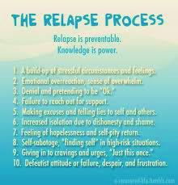
Tapering off Buprenorphine
Following successful stabilization, decisions to decrease or discontinue buprenorphine should be based on a patient’s desires and commitment to becoming medication-free, and on the physician’s support that tapering could be successful. Factors to be considered when determining suitability for long-term medication free status include stable housing and income, adequate psychosocial support, and the absence of any legal problems. (Clinical Guidelines for the use of Buprenorphine in the Treatment of Opioid Addiction, SAMSHA, 2004). Tapering schedule will be determined by the patient and their physician. The behaviorist will be available to offer support to patient.
Positive Reinforcement
Our program recognizes patients who demonstrate progress toward sobriety and health goals. Patients will be rewarded with a certificate for the completion of a class and/or attendance. The treatment team will look for creative ways to acknowledge patient adherence.

