**Opiate Addiction Recovery Resource Guide**

**Summit County Ohio**

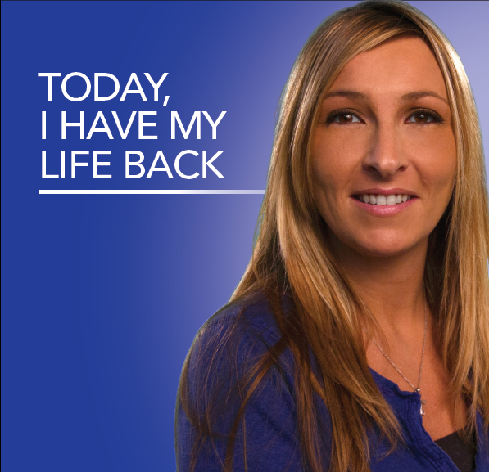

“***People can and do recover. The recovery movement offers a valuable opportunity for people with substance use disorders and their loved ones to get the support they need to gradually return to a healthy and productive life away from the destructive impact of substance use.”***

* Excerpt from *Facing Addition in America: The Surgeon General’s Report on Alcohol, Drugs and Health*

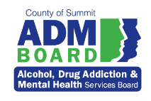 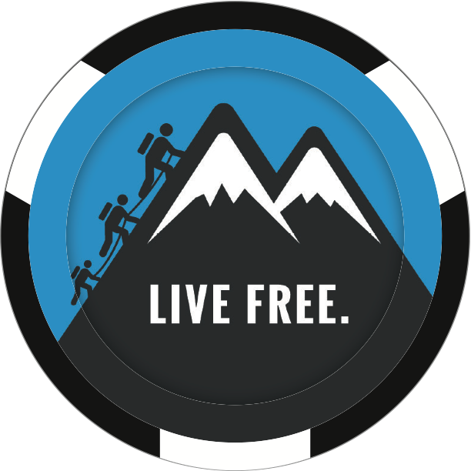 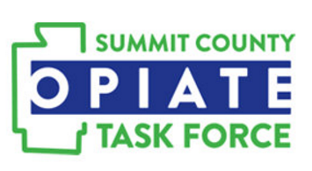

[**www.admboard.org**](http://www.admboard.org)[**cover2.org**](https://cover2.org/) **[www.summitcountyopiatetaskforce.org](http://www.summitcountyopiatetaskforce.org)**

**Addiction does not discriminate and it could happen to anyone.**

Addiction to opiates and/or heroin can begin innocently. It might start with teens experimenting with unused prescription pain medications, perhaps after a medical procedure or recovering from a sports injury. Any of these may lead to addiction to heroin.

Prescription pain medicines and heroin are both opiates. This means they have similar effects in the body. The human brain has a unique capacity to adjust to the chemicals in opiates which both relieve pain and produce a sense of well-being. These same chemical reactions create a dependency on the drug which makes it more difficult to quit. With the right treatment and supports, **recovery is possible**.

**Crisis Services - 330-996-7730**

ADM Crisis Center 15 Frederick Avenue Akron, Ohio 44310

The ADM Crisis Center services are intended to provide 24/7 access and support to adult Summit County residents seeking services for alcohol and other drug problems. Services are provided by a staff of nurses, counselors, social workers, counseling interns, and paraprofessionals. In addition, a physician is on-call 24-hours-a-day, seven-days-a-week.

**Drop-In Services** - The Drop-In Center is for adult, Summit County residents who require a short stay in a safe environment so they may sufficiently recuperate from the immediate effects of slcohol and / or drugs. Clients may be self-referred or brought to the Drop-In Center by police. Clients remain in the center and are monitored for withdrawal symptoms until the effects of the substance have dissipated. Assessments and referral services to community treatment agencies are offered.

**Assessment Services –** Assessment provides chemical dependency evaluations with treatment recommendations and referrals for adult Summit County residents seeking alcohol and chemical dependency treatment services. Clients can be self-referred or referred by family, friends, community agencies or the courts.

**Detoxification -** Detoxification is a set of interventions aimed at managing alcohol and other drug withdrawal. The detoxification process consists of three essential components: evaluation, stabilization, and preparation for entry into substance abuse treatment. The Detoxification Unit provides medically supervised inpatient and outpatient services to adult, Summit County residents who are intoxicated or experiencing withdrawal symptoms.

A**mbulatory (outpatient) Detox -** Ambulatory Detoxification may be an option for individuals with a supportive home environment. An appointment is made with a treatment counselor, medical staff, and a treatment readiness facilitator to discuss expectations, medication, and counseling. The treatment counselor will make a referral for treatment which will continue upon completion of ambulatory detox. If eligible, a physical exam and the first dosage of medication is scheduled. The individual needs to return daily to the ADM Crisis Center initially to receive medications and counseling support for a period of three to five days.

**Outpatient Treatment for Alcohol / Other Drug Services**

Each agency serves adults beginning with an intake process where the individual receives a clinical evaluation and is prescribed a level of services based on assessment of the severity of the problem for which they have sought help. All listed below offer intake assessments and individual and group counseling. Most also provide case management, medication monitoring and intensive outpatient programming. Those with an asterisk * provide medication assisted treatment which combine behavioral therapy and medications to treat substance use disorders.

**Akron UMADAOP** - [**330-379-3467**](tel:+1-330-379-3467)665 W. Market St. - #2D, Akron, OH 44303

**\*Community Health Center** – **Adult** [**330-434-4141**](tel:+1-330-434-4141) **and Adolescent services –330- 730-1888** 725 E. Market Street - Akron, OH 44305

**\*Edwin Shaw Rehab -** [**330-436-0931**](tel:+1-330-436-0931)405 Tallmadge Road - Cuyahoga Falls, OH 44221

**\*Oriana House - 330-535-8116** P.O. Box 1501 - Akron, OH 44309

**Mature Services Avenues to Recovery - 330-253-4597** 415 S. Portage Path - Akron, OH 44320

**\*Rigel Recovery Services - 234-678-5721** 37 Broadway Street - Akron, OH 44308

**Summit County Public Health - 330-923-4891** 1867 W. Market Street, Suite A - Akron, OH 44313

**\*Summa Health System - 330-379-5257** 444 N. Main St. - Akron, OH 44310

**\*Summit Psychological Associates - 330-535-8181** 37 N. Broadway Street - Akron, OH 44305

**Inpatient Treatment**

**Akron General Medical Center - 330-344-1559** 1 Akron General Avenue - Akron, OH 44307

**Summa Akron City Hospital - 330-379-9841** 525 E. Market St. - Akron, OH 44304

**Residential Treatment for Adults**

**Community Health Center** – [**330-434-4141**](tel:+1-330-434-4141)725 E. Market Street - Akron, OH 44305

**IBH Addiction Recovery Center - 330-644-4095** 3445 South Main Street, P.O. Box 26203 - Akron, OH 44319

**Recovery Support Services**

**Recovery Housing -** The County of Summit Alcohol, Drug Addiction and Mental Health (ADM) Services Board provides financial support for local recovery housing that provides a transitional living environment that promotes sobriety and independent living during the early stages of recovery. ADM Board funded recovery housing providers include:

**Truly Reaching You – 330-785-9294**

**Freedom House for Women – 330-785-9720**

**Legacy III – 330-375-0071**

**F I Community Housing – 888-422-2759**

**Recovery Coaches -** Recovery Coaching is a face-to-face or telephone service that considers a person’s stage of recovery and helps to establish a recovery plan to identify and manage relapse warning signs and other issues critical to success in early recovery. Recovery coaches often work with persons after completion of addiction treatment to assist with a positive experience in early recovery and connect persons with additional resources if needed. Recovery coaches or Certified Peer Supporters are persons who have experienced stable recovery from mental illnesses and/or addictions for more than 2 years, and are trained to model a healthy recovery lifestyle. Because their roles differ, a person may have both a sponsor and a recovery coach, since their roles are different and cannot be spanned by any single person.

Recovery coaches are found in addiction treatment agencies, recovery housing agencies, recovery support agencies, and in special docket drug court programs in Summit County. If you are interested in working with a recovery coach, please indicate this to a treatment counselor or court staff, and they can assist you in connecting with a local recovery coach.

**Family and Individual Support and Resources**

**Heroin Anonymous -**  Akron UMADAOP - 665 W. Market St. - #2D, Akron, OH 44303 Meetings: Tuesdays at 4:00pm and Thursdays at 10:00am

**Heroin Anonymous** – Call for meeting times and locations - 330-990-0065 or 330-255-8456

**Nar-Anon -** First Congregational Church - 85 Heritage Drive - Tallmadge, OH 44278 Meetings: Tuesdays at 6:30 pm

**Narcotics Anonymous -** 1-888-GET-HOPE (1-888-438-4673) Call for meeting times and locations

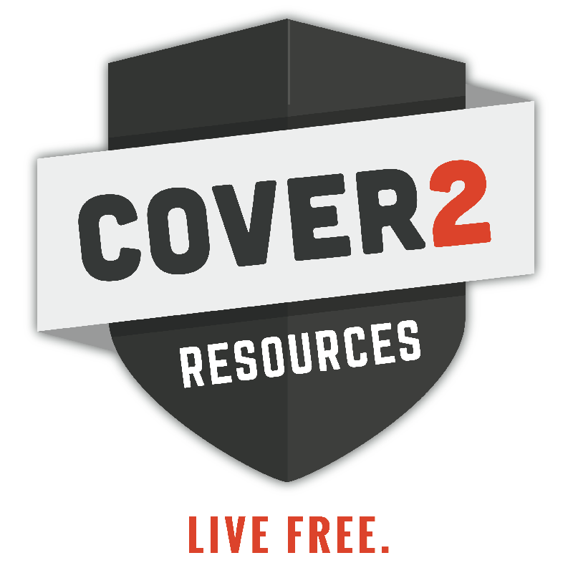**Cover2 Resources – Contact: 330-351-1328 or website: cover2.org**

**The Cover2 Resources** purpose is to spread awareness, educate and advocate for those touched by the opioid epidemic through an ongoing podcast series with new releases twice weekly. Our goal is to shine a spot light on people, places and things that are making a difference in the opioid epidemic and help spread the successful programs throughout Northeast Ohio.

**SOLACE of Summit County -** SOLACE (Surviving Our Loss And Continuing Everyday) Look for meeting times and locations on SOLACE Facebook page: <https://www.facebook.com/solacesummitcounty>

**The Well Grief Support Group – 330-472-7282** Meetings take place every other Wednesday from 6:30pm to 8:00pm at 2656 South Arlington Road, Akron 44319 (Shamp’s Bionics building)

**Additional Resources for Families**

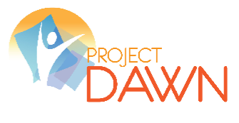

Family members and concerned friends of persons addicted to opiate medications or heroin now have access a new tool in case of an overdose. The administration of Naloxone (also known as Narcan) is saving lives in Ohio.

Naloxone is a medication that can reverse an overdose caused by an opioid drug (heroin or prescription pain medications). When administered during an overdose, naloxone blocks the effects of opioids on the brain and quickly restores breathing. **The effects of Naloxone are temporary and emergency medical treatment is still required.**

Naloxone has been used safely by emergency medical professionals for more than 40 years and has only this one critical function: to reverse the effects of opioids in order to prevent overdose death. Naloxone has no potential for abuse.

Project D.A.W.N. (Deaths Avoided With Nalaxone) is a community-based overdose education and naloxone distribution program available at two sites in Summit County.

**DAWN Clinics (Deaths Avoided with Naloxone)**

**Summit County Public Health - 330-812-3983** 1867 West Market Street, Akron, OH 44313 Project DAWN Clinic Hours: Tuesdays from 3:00 – 6:00

**Edwin Shaw Rehabilitation - 330-436-0950 -** 405 Tallmadge Road, Cuyahoga Falls, Ohio 44221 Project DAWN Clinic hours are Thursdays, 9:00 – 12:00

**SUMMIT SAFE NEEDLE EXCHANGE Program - 330-375-2984** - Summit Safe is a free, anonymous syringe exchange program, which includes overdose prevention training, risk reduction counseling, HIV and hepatitis C testing and education, and one-for-one exchange of syringes.

**Web-based Resources**

**Cover2 Resources - [www.Cover2.org](http://www.Cover2.org)**

**Breaking Barriers – Hope is Alive** – [www.nowwefightforyou.com](http://www.nowwefightforyou.com)

**National Institute on Drug Abuse** - [**www.nida.nih.gov**](http://www.nida.nih.gov/)

**Parents,The Anti-Drug** - [**www.theantidrug.com**](http://www.theantidrug.com/)

**Community Anti-Drug Coalitions of America -** [**www.cadca.org**](http://www.cadca.org/)

**Partnership for a Drug-Free America -** [**www.drugfree.org**](http://www.drugfree.org/)

**Robby’s Voice** <http://www.robbysvoice.com/>

**The Ohio State University College of Pharmacy Generation Rx Initiative**[**www.pharmacy.ohio-state.edu/outreach/generation-rx**](http://www.pharmacy.ohio-state.edu/outreach/generation-rx)

**Start Talking! Campaign:** [**www.starttalking.ohio.gov**](http://www.starttalking.ohio.gov/)

**Drug Free Action Alliance -** [**www.drugfreeactionalliance.org**](http://www.drugfreeactionalliance.org)