My Teaching, Scholarly Activities and Service Work Philosophy

I am the Program Director of the Graduate Program in Chemical Dependency at WSU and I conduct studies and projects in the fields of substance abuse, mental health and disability rehabilitation. I strive to provide my students with experiences and assignments that reflect a community-based approach. My number one goal dating back to when I decided to pursue a PhD in Educational Psychology with an emphasis on Research Design, Statistics and Measurement was to integrate my research education and statistical knowledge to the field of Rehabilitation Counseling in an applied manner. My goal was and continues to be to increase the awareness, knowledge and understanding of the value of research among my students, educators, and professionals.
I teach both undergraduate and graduate courses and receive overwhelmingly positive evaluations from my students. One of the grants I received was the WSU Teaching Innovation Grant. I, and two colleagues, received approximately $13,500 to create and teach an Evidence-Based Practice research course for undergraduates (RHB 3670). The reason I wrote this grant is because I believe that undergraduates benefit from having knowledge of evidence-based practices in rehabilitation.
I involve my students in Community events in Dayton that are related to the opiate epidemic. For example, since 2013 I have been involved in a grant/partnership with East End Community Center, the Dayton police and the Montgomery medication center. This local event, known as Conversation for Change (C4C), is a community based monthly recovery event held at local churches where individuals who are addicted to opiates and their family and friends can attend. A meal is provided, motivational interviewing is used, narcan training is an option as well as treatment providers discussing treatment options. My students who have attended a C4C event have expressed their gratitude for this experience with many underscoring its impact on their career. Dean Keferl was interviewed by WSU media regarding my role in the community and said “Her work is truly exceptional and impactful,” said Joseph E. Keferl, dean of the College of Education and Human Services. “Her work ethic and collaborative style are positively impacting other faculty across the CEHS.” Below is a link to my students reflecting on their experiences with attending many C4C events.

https://www.youtube.com/watch?v=MHYLEt86cQE
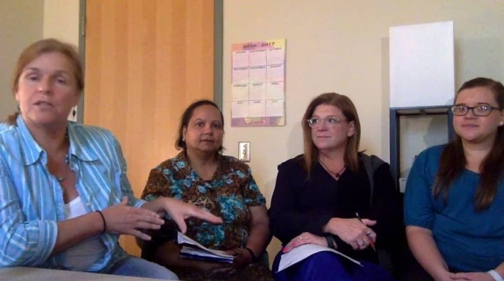 | WSU Student Involvement Interviews
In addition to having my students “have hands on experience” I provide individual mentoring when opportunities exist. I was given the opportunity to mentor an international doctoral student from Mexico during the summers of 2015 and 2016. Another learning opportunity for some of my students is through funded grants. When I have the funds available I will support a Graduate Research Assistant and numerous student worker positions. These students have expressed their gratitude time and time again. This intersection of teaching, research and service work with my students is very exciting to me. Finally, I initiate many collaborative projects with my colleagues through my grants and their particular expertise.
I have an outstanding record of successful scholarship activity to the state, regional, and national levels recognized by my publications, presentations and grants. I have designed, conducted and evaluated both quantitative and qualitative studies and projects in the fields of substance abuse, mental health, and disability rehabilitation. My national service positions deserve attention. I was the Chair for the American Rehabilitation Counseling Association Research and Knowledge Committee (three year appointment, 2015-2018) and I am the Editor for the Journal of Applied Rehabilitation Counseling (5-year commitment).

